**DAILY ONLINE ACTIVITIES SUMMARY**

|  |  |  |  |  |  |  |  |  |
| --- | --- | --- | --- | --- | --- | --- | --- | --- |
| **Date:** | **06/06/2020** | | | | | **Name:** | **Chandana Patil** | |
| **Sem & Sec** | **6th Sem and A Sec** | | | | | **USN:** | **4AL17CS020** | |
| **Online Test Summary** | | | | | | | | |
| **Subject** | | **PAP-III** | | | | | | |
| **Max. Marks** | | **30** | | **Score** | | | **24** | |
| **Certification Course Summary** | | | | | | | | |
| **Course** | Data Visualization using Tableau | | | | | | | |
| **Certificate Provider** | | | **Greatlearning** | | **Duration** | | | **6 Hours** |
| **Coding Challenges** | | | | | | | | |
| **Problem Statement:**  **1.** The program takes a string and removes the nth index character from the non-empty string.  **2.** Write a C program to rotate an array by N positions. | | | | | | | | |
| **Status: Completed** | | | | | | | | |
| **Uploaded the report in Github** | | | | | **yes** | | | |
| **If yes Repository name** | | | | | **https://github.com/chandanapatil/OnlineCourse.git** | | | |
| **Uploaded the report in slack** | | | | | **Yes** | | | |

**Online Test:**

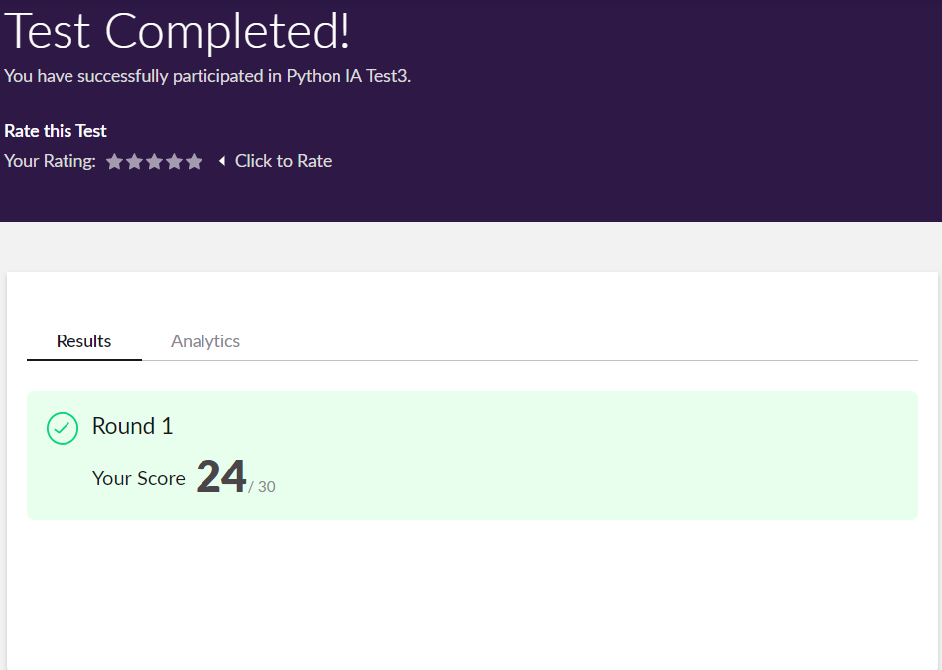

**Certification:**

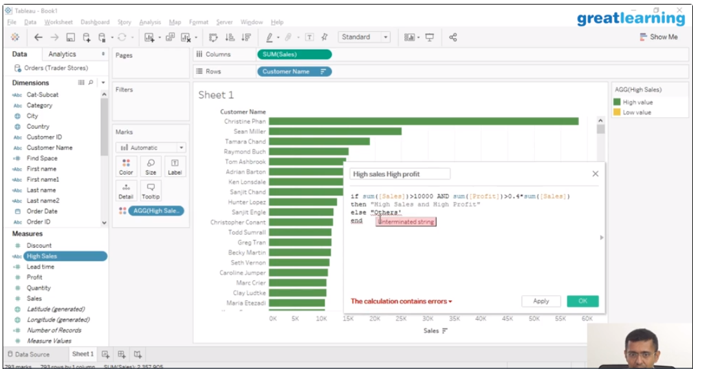

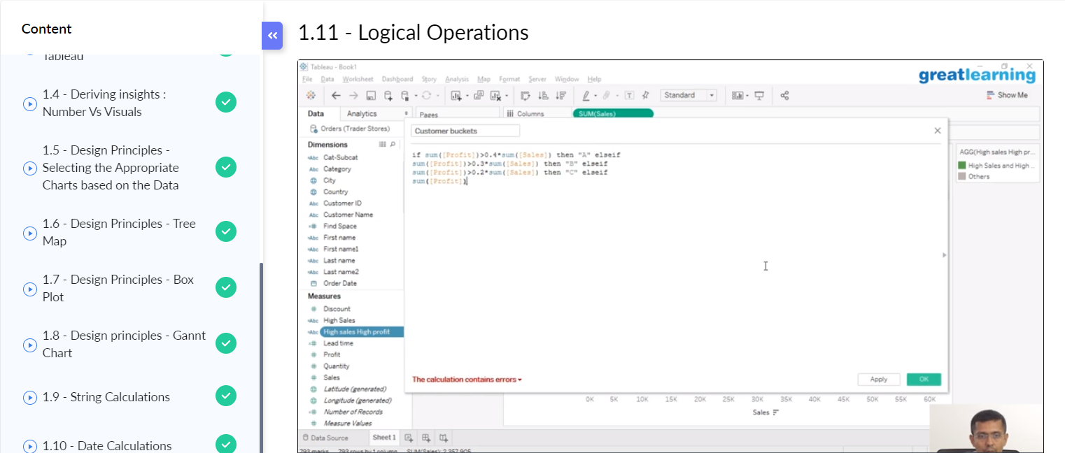

**OnlineCoding:**

**Prog1:** The program takes a string and removes the nth index character from the non-empty string.

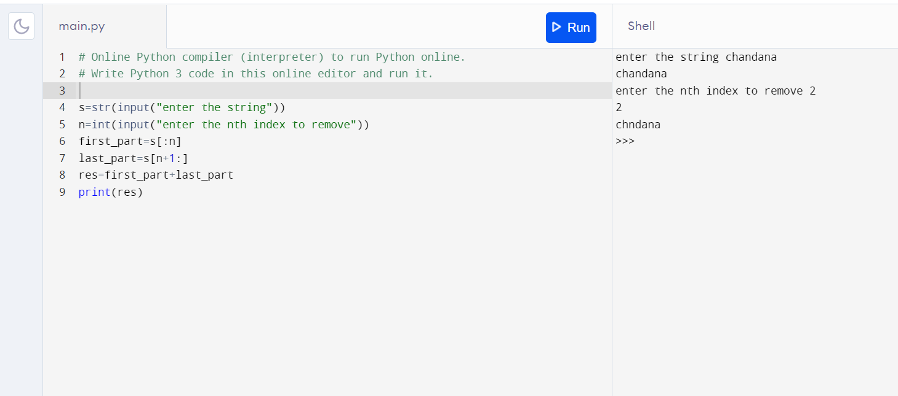

**Prog2:** Write a C program to rotate an array by N positions.

